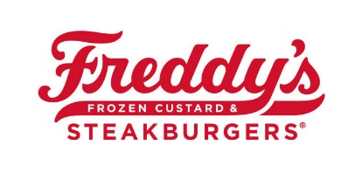
Position Description: Senior Trainer

Job Type: Part-Time / Minimum of 20 hours per week
Salary: $10.50 to $12.50 /hour
Required Approval: GM & MUM Sign-Off

Position Description
Relevant Skills and History:
- Successful history of Guest Service, Team Building and Development of People as a Crew Trainer at MLY Investments, LLC dba Freddy’s of Iowa.
- Aptitude toward Learning, Coaching, and Teamwork.
- Ability to Motivate and Train a diverse staff in a fast-paced environment.
- Must demonstrate a complete and thorough understanding of proper Freducation procedures.
- Strong attention to Detail and Standards while managing time and priorities efficiently.
- Exhibits good character, professionalism and charisma.
- Excellent attention to the Guest Experience, a true example of Hospitality.
- Ability to offer real-time feedback and open to accepting constructive criticism.
- Exhibits detailed attention to Food Safety.
- Ability to assume responsibility for 3 Delegations on their respective operational line (hot or cold).
- Must be performing satisfactorily in current Crew Trainer Role with zero writeups in the prior 6 months.
- Must exhibit the Freddy’s Culture and is established as a Brand Protector.
- Has demonstrated a desire to move into higher levels of leadership at Freddy’s.
- Can be vouched for as a value-added addition to the leadership team in their store.
- Experience Required - Crew Trainer: 6 months.

Physical Requirements:
- Available a variety of hours to include evenings, nights and weekends.
- Ability to work a minimum of 3 shifts totaling to 20 hours per week or more.
- Must be able to work up to an 8-hour shift while standing or walking to perform essential functions.
- Will be required to lift up to forty pounds during the course of a workday.
- Must be able to communicate effectively with guests and team members to ensure the safety of individuals and guest needs.
- Will require bending, stooping, and occasional use of a ladder.
- Reasonable accommodation will be made to those requiring assistance.

Benefits:
- Opportunities for continued advancement to Shift Supervisor.
- Extensive on the job training.
- Opportunity to participate in New Restaurant Openings.
- Flexible scheduling.

