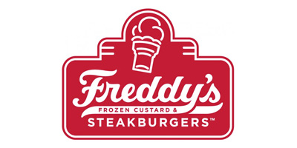
FredHead of the Month Program
The key to a successful FredHead Program is believing in it. The FredHead Program covers all 3 R’s of Retention. It builds Relationships with your team because you are Recognizing their performance and you are Rewarding them for their efforts. The bigger the fanfare that a management team makes of the FredHead Program, the more likely the team members will buy into it and compete for such a revered title.
Steps for Starting the FredHead of the Month Program
- Meet with Store Management to discuss Criteria for a FredHead Nominee and determine who will be responsible for the program each month.
  - Examples of Traits/Behaviors that Exemplify a FredHead:
    - Positive (Smiles, Cheerful)
    - Hard-Working (Stays Busy, Performs to Standards)
    - Upholds 3-Pillars (Cleanliness, Quality, Hospitality)
    - Professional Appearance (In Uniform, Looks Sharp)
    - Energetic (Brings the Energy, Never Drains It)
    - Sets the Example (Minimal Writeups, Leader Each Shift)
  - NOTE - The FredHead of the Month is not a popularity contest, it is a nomination contest. Ultimately, the leaders decide the winner, keeping in mind the criteria from above. Management should not discourage the same person from winning every month. This demoralizes our top performers and damages the credibility of this program. If the same person is the most deserving, no limitations should be placed on winning every single month.

- Establish the FredHead Award. For example, the winner might receive $75 in awards ($25 Restaurant Gift Card, $25 Movie Gift Card, and $25 Freddy’s Gift Card).
  - Additionally, each store will need to purchase a plaque like the example below.

- After completing the above, communicate the FredHead Criteria to the Team Members so they fully understand what is expected of an employee to be nominated and voted “FredHead of the Month”.

The FredHead of the Month Process
- Each month ask all team members to submit a nomination for who they believe should be FredHead of the Month. These can be submitted to the manager in charge, who will keep the nominations in a box in the office.

- Always send a reminder out during the last week of each month to remind team members to submit their nominations

- On the 1st of every month, the manager in charge of the FredHead Program collects the slips and communicates with the other leaders all the nominees via TEAMS
  - NOTE - It is important that the leaders keep in mind that the winner must meet all the criteria discussed in #1. Anyone that does not meet all the criteria cannot be a FredHead of the Month.
  - If team member nominations are not received, discuss performance of employees vs the FredHead requirements in a manager meeting so you can come to an agreement on who was deserving during the time frame

- By the 2nd of each month, the manager in charge of the FredHead Program should do the following:
  - Announce the FredHead of the Month to the entire team.
  - Purchase the Awards as established by your store.
  - Take Picture of the new FredHead and place in plaque.

Finally – CELEBRATE THAT FREDHEAD! The Program is only as special as you make it!

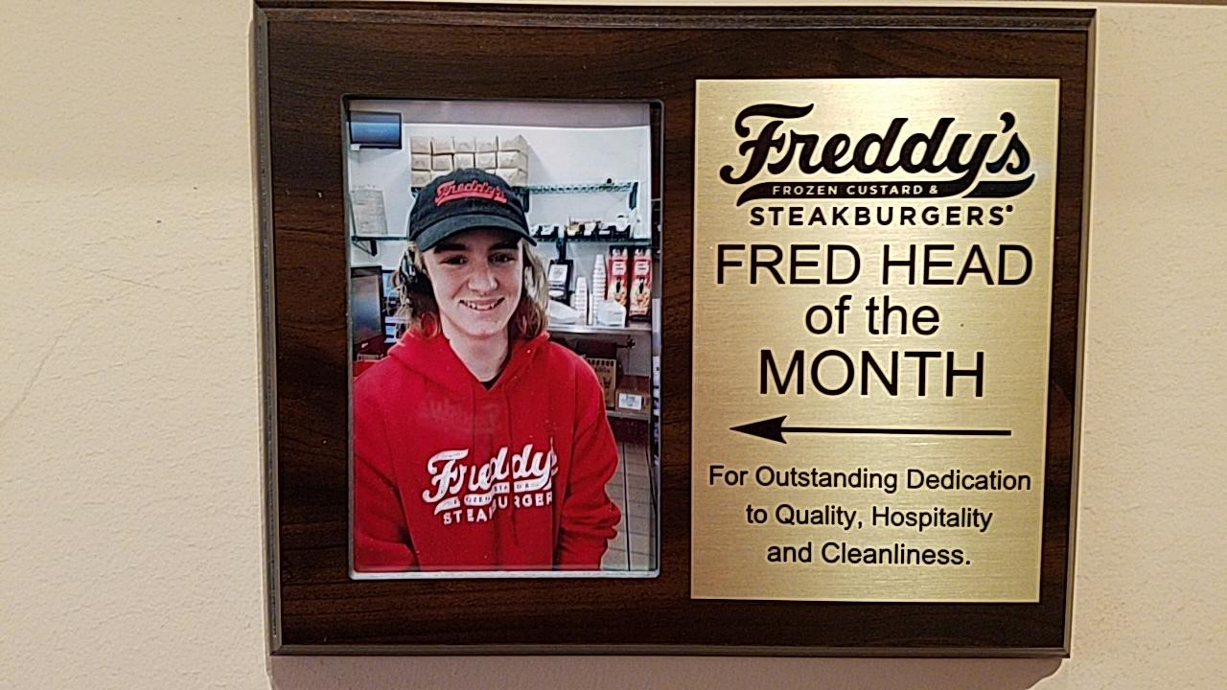

P.R.O.P.S.
See someone going above and beyond for the team? Give them PROPS!

- How it works:
  - Fill out a card anytime you see your fellow teammates going above and beyond and pin it to the board
  - At the end of every month, the managers will collect all cards, validate them, and return them to you
  - Redeem your cards for the prizes shown!
  - That’s it!
- Disclaimers:
  - Lost cards are lost forever. Keep them in a safe place
  - Please take this seriously, any cards that aren’t legitimate will be discarded.
  - Cards can be discarded if the employee has a write up within the duration of the PROPS period

