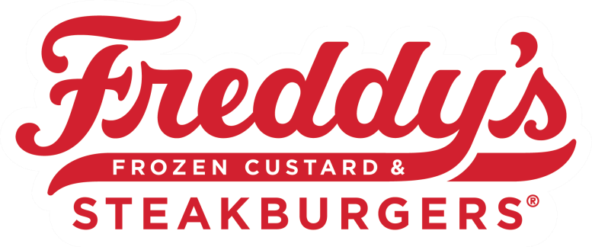
- REVISED 3.1.2022
MLY

INVESTMENTS,

LLC.

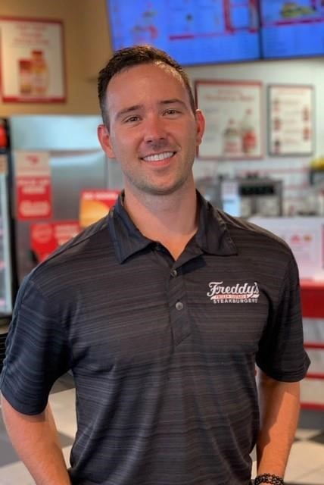

Dear Freddy’s of Iowa Trainer,
On behalf of the entire Freddy’s Family in Iowa, I would like to congratulate you on your promotion to Trainer! Your dynamic personality, professionalism, and commitment to serving our Guests is why you have been chosen for this coveted position. We are confident that you will help us achieve our Vision of becoming a “cult-favorite” in the communities where we have locations.

In our organization, our people are the most important assets we have, and we back up that claim with dedication to providing the best training experience in the industry. We wholeheartedly believe that cultivating the most developed managers and team members in the nation is directly correlated with our achievements. In short, your
new role as a Trainer at Freddy’s is important to us and we want you.
to have an excellent experience while you learn to teach the Freddy’s Way. Your Training Manager and fellow leaders want to set you up for success and are eager to begin working with you!
The legacy of our company and its continued accomplishments makes us one of the most exciting and fastest-growing brands in our industry. This franchise is known for high-powered growth, built from a foundation of incredible teams. For years, we have made business decisions necessary to ensure our success. The most recent decision was promoting you to trainer, and we are certain we made the right choice.
Once again, welcome to the Training Team.
Best Wishes,

Steven Young Director of Operations MLY Investments, LLC.

Trainer Requirements – Why you were chosen.
- Is a leader, a high performer and recognized as an “All-Star”.
- Is outgoing, patient, personable, energetic, receptive, thorough, organized.
- Possesses good communication skills, coaches, and can offer and receive feedback.
- Represents Freddy’s values and is a brand ambassador to include: 100% Compliance, 100 of the time.
- Upholds Freddy’s uniform and professional appearance standards.
- 3 months of HotLine or ColdLine experience.
- Actively works at least 3 shifts per week.
- In “good standing” with no more than one write-up within a 6-month period.
- Understands and practices proper procedures.
- Maintains good rapport with fellow Team Members, management, and guests.
- Has fully completed the Education® Team Member Training Program.
- Sweating the Small Stuff.
- Actively uses 30 Second Coaching opportunities.
- Beacon of Positivity.

Trainer Responsibilities
- Energetically welcomes new Team Member trainees into Freddy’s family.
- Introduces the trainee to the training program, processes, and procedures.
- Gives them complete attention and never leaves the trainee alone during training.
- Always sets the highest standards for trainees and fellow Team Members.
- Accountable for progress of trainees and communicates this progress with Training Manager.
- Always professional while having fun at work.
- Extension of the Management Team

Importance of Proper Training

- Much harder to break bad habits than to train good ones the first time.
- These are the people that are working alongside you and will only be as good as you train them to be.
- You benefit from training people well by having people who can replace your shift, cover time off, etc.

Benefits

- Trainer Hats, Pins, Certificates.
- Participate in special Trainer Outings.
- Pay Increase.
- Free Meals while you train.
- Exclusive Trainer Swag.
- Participation in NROs (new restaurant openings).
- Future Advancement Opportunities.

Responsibilities on Day 1
- Go over Training Program.
- Go over Props Program.
- Go over ordering uniform pieces.
- Introduce them to everyone.
- Be excited and make them feel comfortable/welcome.

Resources

- Training Books and how to utilize them effectively.
- Videos and Quizzes
- Checklists
- Scoop
  - Ops Files
  - Posters
  - Other Videos

Training Tips
- Hands off voices on.
- Trust the process and do not cut corners.
- Use 30 second coaching opportunities.
- Use the resources given to you 100%, 100% of the time.
- Coaching is not always bad, make sure to tell them how well they were doing too.
- Remember the small details and Freddy Factors.
- Teach smiles and make sure they are having a good time.
- Communicate with the Training Manager regularly.

Additional Trainer Responsibilities
- Trainers are effectively the “First Face” of Freddy’s, literally the first person that a Trainee will meet when they join the team.
- You get to give new Trainees a 10-day introduction to the Brand.
- Protecting the Brand means representing Freddy’s through the 3 Pillars of Success.
- Ensure the team around you is doing it “The Freddy’s Way”.
- “Create the Culture” of Good Vibes, Hard Work and Fun!

 
 
Watch Cashier Video
- How to Train the Register.
- Talk about Freddy Factors and talking points.
- Mystery shop expectations.
- Questions.

Watch Custard Video
- Snowball Scoop.
- Proper Portioning.
- Toppings.
- GPS.
- Calling out orders.

Watch Dining Room Video
- Quality table touches.
- GPS.
- Full rounds including patio and restrooms.
- Awareness to jump on register 2.

Watch Drive Video (If applicable)
- Checking bags.
- Greeting Guests.
- Using the headset.
- Verifying orders.
- Window organization.
- Sliding to help others.

I agree that I have been taught and properly understand the expectations of a trainer.
I understand that I must maintain the qualifications of a trainer to remain in my position.
I understand that utilizing training resources is expected 100%, 100% of the time.
I understand the impact that I have on the success of our company as a trainer.
I understand what benefits are available to me as a trainer.
I understand that trainer “perks” may change at any time at the discretion of the DOO.
I agree to give 100% to the training effort 100% of the time.
I understand that I am an extension of the management team and will carry myself as such.

Trainer _ Training Manager

Watch Grill Video
- How to smash and scrape.
- Grill flow.
- Marble and 45-degree angle.
- Visual indicators.
- Communication.

Watch Make Video
- Organization.
- How to bag items.
- Speed tips.
- Sliding.
- GPS.
- Communication.

Watch Fry
- Organization.
- Cook Times.
- Seasoning.
- Filtering.
- Boil Out.
- Communication.

Expo
- Greeting guests and using friendly voices.
- Verifying orders.
- Quality control.
- GPS.

I agree that I have been taught and properly understand the expectations of a trainer.
I understand that I must maintain the qualifications of a trainer to remain in my position.
I understand that utilizing training resources is expected 100%, 100% of the time.
I understand the impact that I have on the success of our company as a trainer.
I understand what benefits are available to me as a trainer.
I understand that trainer “perks” may change at any time at the discretion of the DOO.
I agree to give 100% to the training effort 100% of the time.
I understand that I am an extension of the management team and will carry myself as such.

Trainer______________________ Training Manager ______________________

